MINISTRY OF EDUCATION AND SCIENCE KAZAKHSTAN
"NPJSC Eurasian National University named after L. N. Gumilyov"

EXPLANATORY NOTE
for the course project

BD 2207 Databases

Project topic: Creation of a Database “Information system automation of restaurant work”

Supervisor, associate prof. _____________Ла Л.Л. «___»__________________2024
Done by students of the group
IS-22 _________Suleimenova Inkara «___»__________________204
Project was defended with mark
__________________________

«___»__________________2024

Astana, 2024

Content
Introduction…………………………………………………………………. | 3
Chapter 1. Statement of the problem and analysis of the subject area | 4
- Characteristics of the subject area  - Basic requirements for system functionality and tasks to be solved  - Data volume and structure | 4  4  5
Chapter 2: Database Design ………………………………. | 7
2.1 Reduction to normal forms …………………….. | 7
2.2 Creating an ER model …......... | 10
2.3 Moving from the ER model to database schemas ………..…….. | 11
Chapter 3: Creating a Domain Database  3.1 Creating view, indexes, triggers, procedures  3.2 Creating Subqueries and Cross Join | 15  15  20
Conclusion ………………………………………………………………... | 22
Bibliography…………………………………… | 23

Introduction

In today's world, automation plays a key role in various business areas, including the restaurant segment. From optimizing processes to improving customer service, the introduction of modern information technologies is becoming an integral part of the success of enterprises in the catering industry. In this introduction, we will consider the importance of restaurant business automation, identify its main characteristics and justify the relevance of the chosen topic.

The topic of this course work is related to the automation of the restaurant business. The subject area covers all aspects of the restaurant's operation, from order management and analysis of purchase data. The software in question is designed to optimize the operation of restaurants of various types and scales.

The relevance of the research topic is due to the growing competition in the field of public catering and increased demands from consumers. In conditions of fast pace of life and changing customer preferences, restaurant enterprises are forced to look for ways to optimize processes, reduce service time and improve the quality of service.

The purpose of this course work is to develop and implement software to automate key processes in the restaurant business. Microsoft SQL Server 2022 was chosen as the main implementation platform, which will create a reliable and scalable system.

To achieve this goal, it is necessary to solve the following tasks:

To develop a logical and physical database model that takes into account the specifics of the restaurant business and the requirements for effective data management.
Create software that automates key processes such as order management and analysis of purchase data.

The object of the research is the restaurant business as a whole, and the topic is the automation of its processes using modern information technologies.

Thus, this introduction makes it possible to understand the importance of automation of the restaurant business, substantiates the relevance of the research topic, and also defines the purpose and objectives of the course work.

Chapter 1. Statement of the problem and analysis of the subject area
  - Characteristics of the subject area

Last name and first name of the customer: Stores the names of customers who visit the restaurant.
Phone number: Records the contact numbers of customers and staff.
Reserved table: Indicates the tables that have been reserved by customers.
The day of the visit: Tracks the date on which customers visit the restaurant.
Last visit date: Stores the data of the customer's last visit.
Online ordering: Indicates whether the order was placed online.
Menu: Represents the menu items available in the restaurant.
Last name and first name of the staff: Records the names of staff members working in the restaurant.
Phone number: Stores the contact numbers of staff.
Job Title: Represents the position or job title of staff members.
Payment method: Represents the different methods of payment available.
Order: Represents the details of orders placed by customers.
We can see the result in Figure 1 1 The characteristics of the subject area «Information system automation of restaurant work»

The characteristics of the subject area «Information system automation of restaurant work»
Table 1
Last name and first name of the customer | Menu
Phone number | Last name and first name of the staff
Reserved table | Phone number
The day of the visit | Job Title
Last visit date | Payment method
Online ordering | Order

  - Basic requirements for system functionality and tasks to be solved

- Each attribute (or column) in a table must contain atomic values, meaning it cannot be further divided.
- Each attribute in a table must have a unique name.
- Each cell in the table must contain a single value, not a list or set of values.
Description of a data structure in first normal form
Table 2
The unique number of the customer | Unique drink number
Last name of the customer | Name of the drink
First name of the customer | Drink category
Phone number | The price of the drink
Last visit date | The price of the drink
Unique booking number | The unique number of the dish
Unique table number | Name of the dish
Number of seats | The category of the dish
Visit day | The price of the dish
Bill | The ingredients of the dish
Unique order number | The staff's unique number
Payment method | Job Title
Unique payment number | Salary
Unique online order number | Phone number
Unique order number | Date of hiring

Here you can see diagram of description of a data structure in first normal form on Figure 1:

Figure 1
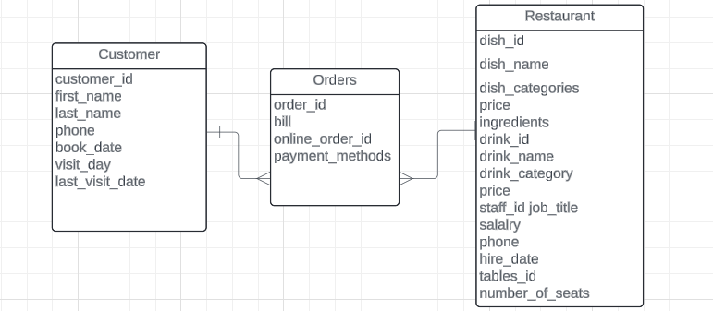
Figure 1. Description of a data structure in first normal form

Detailed Description of Actions:

- Customer Table:
Split the original structure into a separate table for customers, ensuring each attribute represents a unique aspect of the customer, such as their ID, name, contact details, and visit history.
- Order Table:
Extract attributes related to orders, such as order id, online order id, billing information, and payment methods, into a distinct table.
- Restaurant
Table containing unique drink identifiers, names, categories, prices, and dish identifiers, names, categories, prices, and ingredient lists, along with store staff information, including unique staff IDs, job titles, salaries, contact numbers, and hiring dates. Additionally, include attributes related to bookings, such as unique booking numbers, table numbers, seating capacity, and visit details, in the same table.

  - Data volume and structure

- Customer table
Data volume: The customer table is expected to store information about each customer of the restaurant. The amount of data depends on the number of customers who visit the restaurant.
Data structure: Includes the attributes customer_id, first_name, last_name, phone, book_date, visit_day and last_visit_date.
- Order Table
The amount of data: Depends on the number of orders placed in the restaurant.
Data structure: Includes order ID, customer ID, staff ID, beverage ID, dish ID, invoice ID and payment ID.
- Restaurant table
The amount of data: The restaurant table is expended to store information about the work of the restaurant. The amount of data depends on the menu, staff.

Chapter 2: Database Design
  - Reduction to normal forms
The second normal form (2NF) assumes that the table is in the first normal form and all its attributes, which are not keys, are completely dependent on the primary key. In other words, each non-key attribute should be functionally dependent on the entire primary key, not on a part of it.
Let's apply this normal form to our tables:
1. Customers (Clients):
The second normal form has already been achieved, since each attribute (for example, first_name, last_name, phone) depends entirely on the primary key (customer_id).
Customer table
Table 1
customer_id
first_name
last_name
phone
book_date
visit_day
last_visit_date

2. Tables:
I have brought the table to 2NF, since the number_of_seats attribute depends on the entire primary key tables_id.
Tables table
Table 2
tables_id
number_of_seats
3.Booked table (Reserved tables):
I have brought this table into the second form, since each attribute (for example, tables_id) depends on the entire primary key book_id.
Booked table
Table 3
book_id
tables_id
customer_id
4. Menu
The menu table is also in 2NF, since each attribute depends on the entire dish_id and drink_id primary key.
Menu table
Table 4
dish_id
dish_name
dish_categories
price
ingredients
drink_id
drink_name
drink_category
price
5. Staff:
The staff table is in 2NF, since each attribute depends on the entire primary key staff_id.
Staff table
Table 5
staff_id
first_name
last_name
job_title
salary
phone
hire_date

6. Payment_methods (Payment Methods):
This table is already in its second normal form, since each attribute depends on the entire primary key payment_id.
Payment methods table
Table 6
payment_id
method_name
7. Orders:
The orders table is also in 2NF, since the attributes depend on the primary keys order_id and online_order_id.
Orders table
Table 7
order_id
customer_id
staff_id
drink_id
dish_id
bill
payment_id
online_order_id
To bring the table to the third normal form (3NF), you need to make sure that each non-key attribute functionally depends only on the primary key and does not depend on other non-key attributes.
In general, most of the tables follow the third normalization rule, with the exception of Menu and Orders, so let's work with them.
8. Dish (Dish):
The dish table is also in 3NF, since each attribute depends on the entire dish_id primary key.
Dish table
Table 8
dish_id
dish_name
dish_categories
price
ingredients
9. Drink:
The drinks table is also in 3NF, since each attribute depends on the entire drink_id primary key.
Drink table
Table 9
drink_id
drink_name
drink_category
price
10. Orders:
The orders table is also in 3NF, since each attribute depends on the entire order_id primary key.
Orders table
Table 10
order_id
customer_id
staff_id
drink_id
dish_id
bill
payment_id
11. Online orders:
The online orders table is also in 3NF, since each attribute depends on the entire order_id primary key
  - Creating an ER model
ER diagrams (entity-relationship) are a graphical representation of the database structure that displays entities (also known as tables), the attributes of these entities and the relationships between them. They are an important tool for database design, helping developers and analysts better understand the structure of data and the relationships between them.
In an ER diagram, entities are usually represented as rectangles and attributes as ovals, the relationships between entities are indicated by lines and arrows indicating the type of relationship (one to one, one to many, many to one or many to many).
ER diagrams help to visualize the data structure, which simplifies the process of designing and understanding a database, especially when working with more complex systems. They are also used for documentation and communication between development team members and stakeholders.
Here in Figure 2 we see the ER diagram:

Figure 2
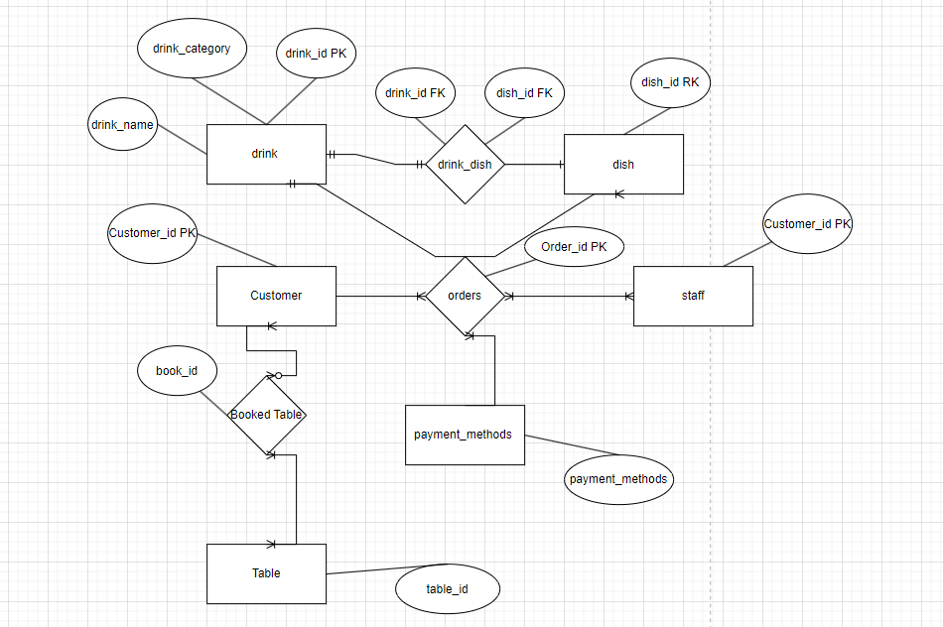
Figure 2. ER diagram

  - Moving from the ER model to database schemas
The transition from an ER model (entity-relationship) to database schemas is the process of converting a conceptual data model, represented as an ER diagram, into a physical database structure, that is, a set of tables, relationships, and constraints that implement this model.

This process includes the following steps:

ER Diagram Analysis: Developers analyze an ER diagram to understand entities, their attributes, and the relationships between them.
Defining tables and relationships: Based on information from the ER diagram, database tables and relationships between them are determined. Each entity turns into a table, and each relationship between entities defines the relationships between the tables.
Defining table attributes: Attributes of each entity from the ER diagram are converted into columns in the corresponding database tables.
Defining primary and foreign keys: Primary keys are defined for each table, and foreign keys are set for relationships between tables to ensure data integrity.
Defining data integrity constraints: Constraints such as uniqueness of values and referential integrity are defined to ensure proper data storage and error prevention.
Creating scripts for creating tables: Based on a specific database structure, SQL scripts are developed to create tables, relationships, and constraints.
Implementation and testing: The created scripts are executed on the database server to create a database schema. After that, testing is carried out to make sure that the database is working correctly and meets the requirements.
Thus, the transition from the ER model to database schemas is the process of specifying and implementing the data structure presented at the conceptual level in the ER diagram, in the form of specific tables, relationships and constraints in a real database.
A total of 10 tables were received: customers, tables, reserved table, dish, drink, snack bar, staff, payment methods, orders and online orders. What can be done for this:
1. Open SQL Server Management Studio.
2. Click on the new query. Here we first create a database by attributing:

create database restaurant

3. After quickly creating the database, we start creating tables using the create table syntax table_name(data type column name, ...)
create table customers
(customer_id int not null primary key,
first_name nvarchar(20) not null,
last_name nvarchar(20) not null,
phone int,
book_date date,
visit_day date,
last_visit_date date default null)

create table [tables]
(tables_id int not null primary key,
number_of_seats int)

create table booked_table
(book_id int not null primary key,
tables_id int references [tables](tables_id), --ссылочный ключ,
customer_id int not null references customers(customer_id), --ссылочный ключ,
)

create table dish
(dish_id int not null primary key,
dish_name nvarchar(20) not null,
dish_categories nvarchar(20) not null,
price int,
ingredients varchar(500))

create table drink
(drink_id int not null primary key,
drink_name nvarchar(20) not null,
drink_category nvarchar(20) not null,
price int
)

create table drink_dish
(drink_id int references drink(drink_id),
dish_id int references dish(dish_id))

create table staff
(staff_id int not null primary key,
first_name nvarchar(50) not null,
last_name nvarchar(50) not null,
job_title nvarchar(20) not null,
salary int not null,
phone bigint not null,
hire_date date
)

create table payment_methods
(payment_id int not null primary key,
method_name varchar(50) not null)

create table orders
(order_id int not null primary key,
customer_id int references customers(customer_id), --ссылочный ключ
staff_id int references staff(staff_id), --ссылочный ключ
drink_id int references drink(drink_id), --ссылочный ключ
dish_id int references drink(drink_id), --ссылочный ключ
bill int,
payment_id int references payment_methods(payment_id))

create table online_orders (
online_order_id int not null primary key,
customer_id int references customers(customer_id),
o_date date,
drink_id int references drink(drink_id),
dish_id int references dish(dish_id),
bill int,
payment_id int references payment_methods(payment_id)
)

Figure 3
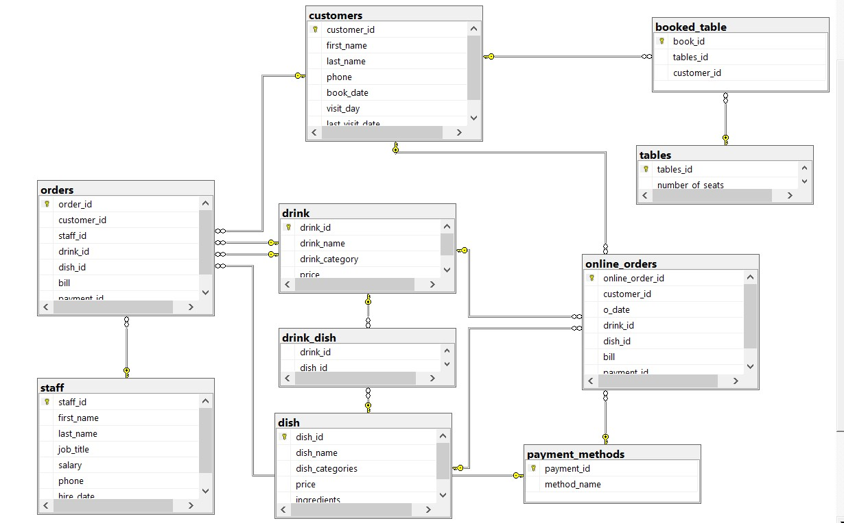

Figure 3. Database scheme

4. I added not null, primary key, default constraints to the tables.

Not null is a constraint that ensures that the attribute value cannot be NULL, that is, missing or undefined. When creating or modifying an entry in a table, an attribute marked as NOT NULL must have a value.

A primary key is an attribute or combination of attributes that uniquely identifies each entry in a table. It guarantees the uniqueness of the values in a column or group of columns and provides quick access to records by key. The primary key also automatically creates a unique index for the table.

DEFAULT is the default value for the column that will be used if the value is not explicitly specified when inserting a new row into the table. If a value is not provided for a column that has DEFAULT, the default value will be used.
5. At this stage, I have an error. Initially, when I created date strings, the datetime data type was char (10) NOT NULL CHECK (odate LIKE ‘_ _/_ _/_ _ _ _'). But then, when I tried to insert the data, a similar error occurred:

Figure 4
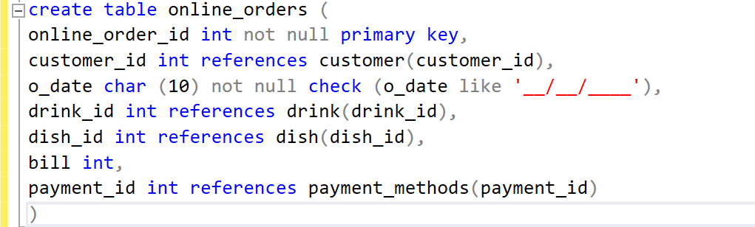 Figure 4. Column with data type: char (10) NOT NULL CHECK (odate LIKE ‘_ _/_ _/_ _ _ _')
Figure 5
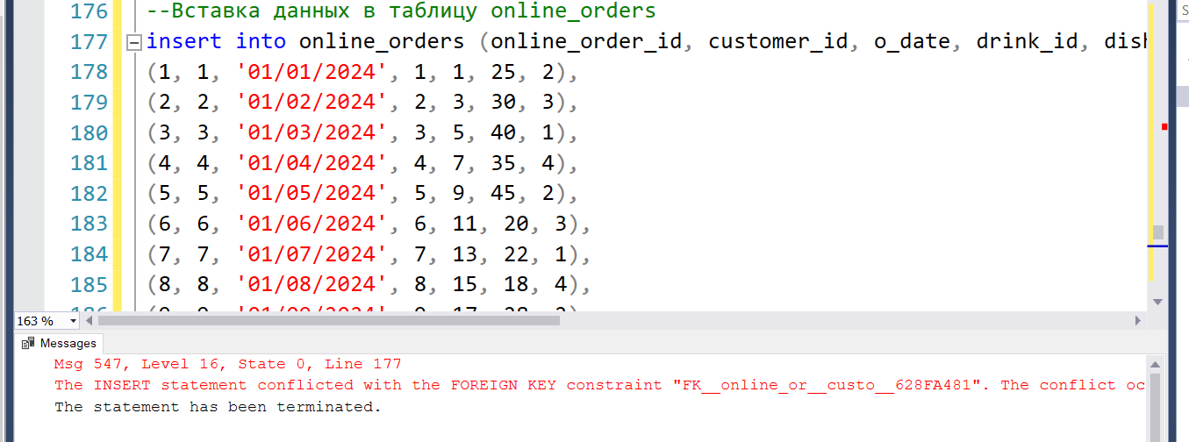
Figure 5. Error

Chapter 3: Creating a Domain Database
  - Creating view, indexes, triggers, procedures
- A view is a virtual table that is based on the results of executing a query against one or more real tables in the database. A View does not store data physically, but is a set of data defined according to a query that can be executed as if it were a real table.

The main advantages of using views:

- Simplify data access: Views can combine data from multiple tables and provide the user with a simple and intuitive interface to access this data.
- Hiding Data Complexity: Views allow you to hide complex queries and data structure from the end user by providing only the necessary information.
- Data security: Views can be used to configure the level of data access by restricting access to certain columns or rows of data.
- Query reuse: Views can be used to store frequently used queries, which avoids re-writing queries in different parts of the application.

I have created a view that combines information about orders from the orders and online_orders tables and that gives all the information about orders. Called her OrderDetails.

create view OrderDetails as
select
o.order_id,
c.first_name + ' ' + c.last_name as customer_name,
s.first_name + ' ' + s.last_name as staff_name,
o.bill,
p.method_name as payment_method,
case
when o.drink_id is not null then 'Drink: ' + d.drink_name
when o.dish_id is not null then 'Dish: ' + di.dish_name
end as item_name,
case
when o.drink_id is not null then d.price
when o.dish_id IS NOT NULL then di.price
end as item_price,
case
when o.drink_id is not null then 'Drink'
when o.dish_id is not null then 'Dish'
end as item_type
from
orders o
left join
customers c on o.customer_id = c.customer_id
left join
staff s on o.staff_id = s.staff_id
left join
payment_methods p on o.payment_id = p.payment_id
left join
drink d on o.drink_id = d.drink_id
left join
dish di ON o.dish_id = di.dish_id

union all

select
oo.online_order_id,
c.first_name + ' ' + c.last_name as customer_name,
null as staff_name,
oo.bill,
p.method_name as payment_method,
case
when oo.drink_id is not null then 'Drink: ' + d.drink_name
when oo.dish_id is not null then 'Dish: ' + di.dish_name
end as item_name,
case
when oo.drink_id is not null then d.price
WHEN oo.dish_id is not null then di.price
end as item_price,
case
when oo.drink_id is not null then 'Drink'
when oo.dish_id is not null then 'Dish'
end as item_type
from
online_orders oo
left join
customers c ON oo.customer_id = c.customer_id
left join
payment_methods p ON oo.payment_id = p.payment_id
left join
drink d ON oo.drink_id = d.drink_id
left join
dish di ON oo.dish_id = di.dish_id;

- Index is a data structure created to speed up the operations of searching and sorting records in a table. Indexes allow the database to efficiently find the desired data rows, reducing query execution time, especially when working with large amounts of data.

The main characteristics of the indexes:

- Acceleration of search operations: Indexes are created on one or more columns of a table and allow the database to quickly find rows that match certain conditions in a SELECT query.
- Performance improvement: Using indexes can significantly reduce the time required to perform lookup, sort, and join tables, especially in the case of large amounts of data.
- Improving efficiency when updating data: Although indexes speed up search operations, they can slow down data insertion, update, and deletion operations, since when they are performed, the database must also update the corresponding indexes.
- Resource consumption: Indexes take up additional space in memory and on disk, which can lead to increased use of system resources. Therefore, it is necessary to assess the balance between speeding up operations and the cost of storing indexes.
The index of the customer_id field. This index will help speed up the operations of searching and filtering orders by customer ID.

create index idx_customer_id on online_orders (customer_id)

The index for the payment_id field. This index can help with transactions related to order payment methods.

create index idx_payment_id on online_orders (payment_id)

Each of these indexes will improve the performance of queries using the corresponding fields by quickly finding and filtering data.

- A trigger is a special type of stored object that is automatically executed (triggered) when certain events occur in the database. These events can be changes in the data (for example, inserting, updating, or deleting rows in a table) or changes in the database structure itself.

Triggers allow you to automate the execution of database operations in response to certain user actions or data changes. For example, a trigger can be used to maintain data integrity, audit changes, or perform complex calculations.

Triggers usually consist of two main parts: the conditions (or events) under which the trigger should be triggered, and the actions that are performed when the trigger is triggered. Actions may include executing SQL code, calling stored procedures, or other data manipulation.

Examples of events where a trigger can be triggered include inserting, updating, or deleting rows in a table, as well as changing the structure of a table (for example, creating a new table or changing its columns).

I have created a trigger for the orders table that will update the total amount of the order after each update:

create trigger trg_update_order_total
on orders
after insert, update
as
begin
update orders
set bill = (select sum(d.price + dr.price) from inserted i
join dish d on i.dish_id = d.dish_id
join drink dr on i.drink_id = dr.drink_id)
where order_id in (select order_id from inserted)
end;
- A Stored Procedure is a precompiled set of SQL statements that is stored in a database and can be called from an application or other program to perform a specific task or operation.

Stored procedures usually consist of a sequence of SQL queries, logical constructs, variables, and other elements of a database-supported programming language (for example, PL/SQL for Oracle, T-SQL for Microsoft SQL Server).

The main advantages of stored procedures:

Performance improvement: Stored procedures are compiled and stored in the database, which reduces query processing time and reduces network load.
- Security: Stored procedures can use database security mechanisms to restrict access to data and protect against unauthorized access.
- Code reuse: Stored procedures can be called from various applications and queries, ensuring code reuse and reducing duplication.
- Transaction Management: Stored procedures can be included in database transactions, which ensures data integrity and reversibility of operations.
- Network traffic reduction: Since queries and operations are performed directly on the database server side, the amount of network traffic between the client application and the server is reduced.
- Stored procedures are widely used to implement business logic, data processing, report generation, and other tasks that require complex database operations.

The first stored procedure is the menu. I did it for two reasons. The first is to restrict access to data. I have restricted access to menu data only through certain access points, for example, through a stored procedure. This helps to manage security and prevent direct access to database tables.
And the second is performance improvement. In the case of large amounts of data or high load on the database server, performing server-side operations using stored procedures can lead to improved performance and efficiency of the application.
create procedure Menu
as
begin
select
dish.dish_name,
dish.dish_categories,
dish.ingredients,
dish.price as dish_price,
drink.drink_name,
drink.drink_category,
drink.price as drink_price
from dish
join drink_dish as a on dish.dish_id = a.dish_id
join drink on a.drink_id = drink.drink_id
order by dish_categories, drink_category
end

The second stored procedure is the purchase analytics for Orders. I did it for three reasons. The first two are described above, and the last one is the frequency and volume of data. When my restaurant has a large number of transactions and purchase data is updated frequently, using a stored procedure can help ensure quick access to data and efficient execution of analytical queries.

create procedure sales_analytics
as
begin
with salescounts as (
select
customers.visit_day,
dish.dish_name,
drink.drink_name,
count(*) as sales_count,
row_number() over (partition by customers.visit_day order by count(*) desc) as rn
from
orders
left join
dish ON orders.dish_id = dish.dish_id
left join
drink ON orders.drink_id = drink.drink_id
left join
customers on orders.customer_id = customers.customer_id
group by
customers.visit_day, dish.dish_name, drink.drink_name
)
select
visit_day,
dish_name,
drink_name,
sales_count
from
salescounts
where
rn = 1;
end

And the last stored procedure is the purchase analytics for Online Orders.
create procedure sales_analytics_online
as
begin
with salescountsonline as (
select
customers.visit_day,
dish.dish_name,
drink.drink_name,
count(*) as sales_count,
row_number() over (partition by customers.visit_day order by count(*) desc) as rn
from
online_orders
left join
dish ON online_orders.dish_id = dish.dish_id
left join
drink ON online_orders.drink_id = drink.drink_id
left join
customers on online_orders.customer_id = customers.customer_id
group by
customers.visit_day, dish.dish_name, drink.drink_name
)
select
visit_day,
dish_name,
drink_name,
sales_count
from
salescountsonline
where
rn = 1
end

  - Creating Subqueries and Cross Join
- A subquery is a query that is executed inside another query. It is used to extract data from a database based on the results of another query. Subqueries can be used in various parts of an SQL query, such as WHERE conditions, HAVING expressions, FROM expressions, etc. They allow you to perform more complex data sampling operations by combining the results of various queries.

--Getting information about customers who have made online orders
select *
from customers
where customer_id in (select customer_id from online_orders);

--Getting a list of employees who have accepted orders from a certain customer:
select distinct s.staff_id, s.first_name, s.last_name
from staff s
join orders o on s.staff_id = o.staff_id
where o.customer_id = (select customer_id from customers where last_name = 'Smith');

--find the customer_id whose average check is larger than the average check of most
select customer_id, avg(bill) as avg_bill
from orders
group by customer_id
having avg(bill) > (select avg(bill) from orders);

--find the customer_id whose invoice amount is greater than the maximum invoice
select customer_id, sum(bill) AS total_bill
from orders
group by customer_id
having sum(bill) > (select max(bill) from orders);

--find all the information about the customers who booked the table and who left their rooms
select *
from customers
where customer_id in (select customer_id from booked_table)
and phone is not null;

- CROSS JOIN in SQL is used to create a combination of each row from one table with all rows from another table. This means that each row from the first table will be merged with each row from the second table. The result of the CROSS JOIN will be a new table containing all possible combinations of rows from both tables.

For example, if we have table A with three rows and table B with two rows, then the result of CROSS JOIN will be a table with six rows (3 * 2 = 6), where each row from table A will be combined with each row from table B.

CROSS JOIN can be useful in cases where you need to perform a join operation without any connection conditions between tables. However, it should be used with caution, as it can lead to a large number of rows as a result, especially if the tables that are being merged contain a large amount of data.

--Getting all possible combinations of dishes and drinks:
select d.dish_name, dr.drink_name
from dish d
cross join drink dr;

--Getting all possible combinations of employees and tables:
select s.first_name, t.tables_id
from staff s
cross join tables t;

Conclusion

In conclusion, it is safe to say that the restaurant business is in a constant state of development and change. Nowadays, when technology plays a key role in everyday life, its introduction into the restaurant business is becoming a necessity, not just a fashion trend. Automating routine processes such as product accounting, order processing, and personnel management frees up valuable time for employees, allowing them to focus on more important tasks such as quality customer service.

Moreover, automation not only simplifies the life of the staff, but also increases the efficiency of the entire enterprise. Electronic warehouse and order management systems help reduce waiting and order processing time, which in turn improves the overall quality of service and customer satisfaction.

Finally, automation also helps to reduce operating costs and minimize the human factor in the maintenance process. This makes the restaurant business more resilient to changes in external conditions and more competitive in the market.

Thus, the introduction of technology and automation of routine in the restaurant business play a key role in ensuring its success and prosperity in the modern world.

Bibliography

- Ramez Elmasri. Shamkant B. Navathe. FUNDAMENTALS OF Database Systems SEVENTH EDITION: book-2016-1239p
- Barkov I.A. - Object-oriented programming: textbook - Lan Publishing House - 2019-- ISBN: 978-5-8114-3586-9 - Electronic text // EBS Lan - URL: https://e.lanbook.com/book/119661
- Ivanova G.S. Programming technology: textbook / Ivanova G.S. — Moscow: KnoRus, 2018. — 333 p. — (for bachelors). — ISBN 978-5-406-06109-1. — URL: https://book.ru/book/926372 (date of access: 10/10/2019). — Text: electronic.
- C.J. Date. SQL and Relational Theory: How to Write Accurate SQL Code: textbook – 2009 – 432p
- Joshua M. Stiglitz. SQL Programming & Database Management For Noobs: textbook – 2016 – 194p
- Sergey Skudaev. Learn SQL by Examples: Examples of SQL Queries and Stored Procedures for MySQL and Oracle: textbook – 2012 – ISBN: 1546996346

